Expansion to the boundaries of the Maroondah Phylloxera Infested Zone
Industry Notice 23 May 2019
New infestations of grape phylloxera have been detected at St Andrews, Coldstream and Seville.

background to the detection
In response to new detections of grape phylloxera at St Andrews, Coldstream and Seville, an expansion to the boundaries of the Maroondah Phylloxera Infested Zone (PIZ) is in the process of being declared. This boundary expansion will comply with national phylloxera management requirements (please refer attached map).

information for GROWERS
Grape growers are reminded to enact on-farm biosecurity measures to help mitigate the threat of grape phylloxera establishing on their vineyards.
These measures include:
- Reminding visitors and contractors to use footbaths before entering the vineyard.
- Ensuring contract staff disinfest equipment and clothing and park vehicles outside of vineyards.
- For movement within the Maroondah PIZ, ensuring all agriculture equipment has been cleaned and, preferably, heat treated prior to entering the vineyard.

mandatory reporting
Report all suspected grape phylloxera detections by contacting 136 186 or emailing market.access@ecodev.vic.gov.au

phylloxera host MATERIAL MOVEMENT conditions for Movement out of a Phylloxera infested zone (PIZ) INTO ANOTHER PIZ

Whole wine grapes
Prohibited unless permitted by Agriculture Victoria to do so and consigned under the following conditions:
- packed in bins cleaned free of soil and plant material before delivery; and
- loaded into transport vehicles on a hard surface (not within the vineyard); and
- bins are not filled within 200mm of the top; and
- bins are securely covered; and
- transport vehicles cleaned free of soil and organic matter; and
- transported via an approved route; and
- having an emergency response plan approved by an inspector, for handling spillages; and
- accompanied by a permit issued by Agriculture Victoria.

Must and unfiltered juice
Prohibited unless permitted by Agriculture Victoria to do so and consigned under the following conditions;
- in the case of whole must, be prepared from de-stemmed crushed grapes; and
- in the case of juice, be prepared from crushed grapes; and
- consigned in sealed tankers or containers, cleaned free of soil and organic matter; and
- transported via an approved route; and
- having an emergency response plan approved by an inspector, for handling spillages; and
- accompanied by a permit issued by Agriculture Victoria.

Marc
Prohibited unless permitted by Agriculture Victoria to do so and consigned under the following conditions:
- has undergone fermentation for at least four days; or
- has been composted for at least 3 months -
- at least 500 m from grapevines; or
  - in a secure, segregated location; and
- consigned in sealed containers, cleaned free of soil and organic matter; and
- transport vehicles cleaned free of soil and organic matter; and
- be accompanied by a permit issued by Agriculture Victoria.

Cuttings, rootlings, and potted vines
Movement of cuttings, rootlings and potted vines is prohibited from a PIZ.

Soil
Movement of soil is prohibited, except in small quantities obtained for diagnostic or research purposes (refer to conditions for diagnostic samples below).
Diagnostic samples and germplasm
Movement of diagnostic samples and germplasm can only occur under conditions stipulated in a permit issued by Agriculture Victoria.

Agricultural equipment and packages
Prohibited unless permitted by Agriculture Victoria to do so and consigned under the following conditions;
  - thoroughly cleaned with a steam cleaner or with high pressure hot water to remove all soil and plant debris; and
  - disinfested by:
- steam applied at a temperature above 100°C, as measured at the steam outlet; or
- immersion in hot water (>70°C) for at least 2 minutes at temperature, or
- placing in a dry heat room at a temperature of 45°C for at least 90 minutes or at a temperature of 40°C for at least 180 minutes; and
- accompanied by a Plant Health Certificate, or a Plant Health Declaration issued by an Agriculture Victoria approved person
Note: for mechanical harvesters, disinfestation by dry heat is compulsory.

For movement FROM A PIZ to a Phylloxera Risk Zone (PRZ) or Phylloxera Exclusion Zone (PEZ):

Whole wine grapes
Movement of whole wine grapes is prohibited from a PIZ into a PRZ or PEZ.

Must and unfiltered juice
Prohibited unless permitted by Agriculture Victoria to do so and consigned under the following conditions:

Consignor requirements:
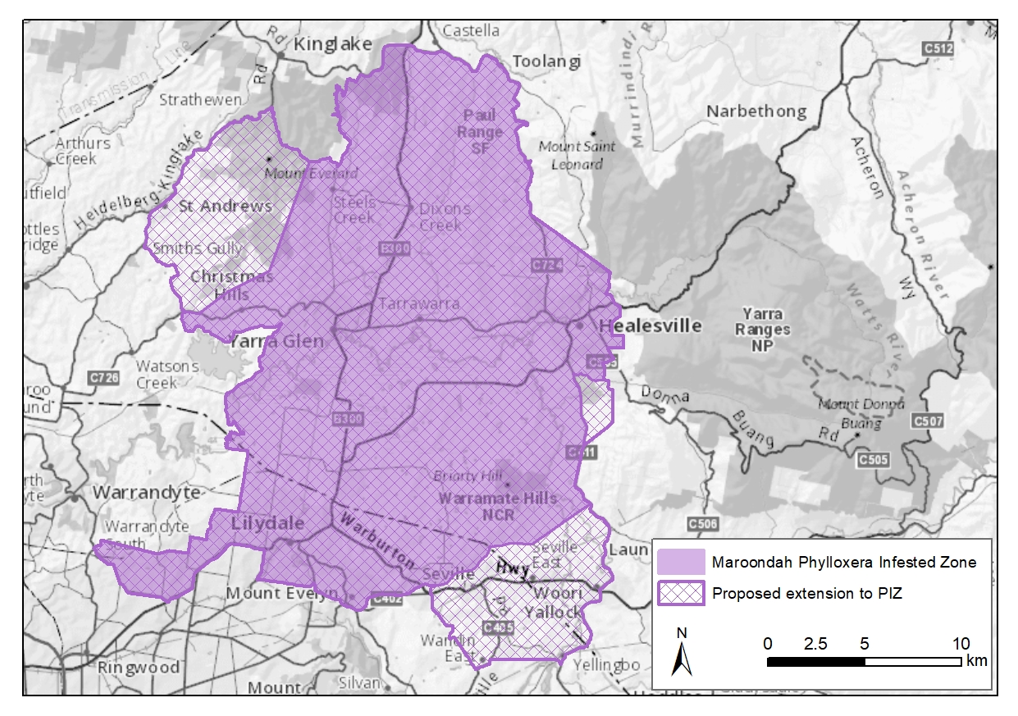
- as per PIZ conditions; or
- accompanied by a Plant Health Declaration issued by business accredited under ICA-22.

Consignee requirements:
- consignment accompanied by either a permit issued by Agriculture Victoria, or a Product Movement Declaration issued by an ICA-22 accredited business; and
- the receiving business must be accredited under ICA-22; or
- the business must be inspected by Agriculture Victoria and found to have suitable systems in place for receival of must or juice including:
  - a dedicated unloading area;
  - signage indicating dedicated roadways and no-entry areas;
  - waste disposal procedures;
  - spill control procedures.

Marc, soil, diagnostic samples, germplasm, agricultural equipment and used packages
Prohibited unless permitted by Agriculture Victoria to do so and consigned under the conditions defined for PIZ to PIZ movement.

Cutting, rootlings and potted vines
Movement of cuttings, rootlings and potted vines is prohibited from a PIZ into a PRZ or PEZ.

Further Information
Further notification will be provided by Agriculture Victoria once the expansion to the boundaries of the Maroondah PIZ is declared.
For more information, please contact Agriculture Victoria by telephone on 136 186 or email: market.access@ecodev.vic.gov.au

